**YOLO Model Fine-Tuning & Inferencing Report**

**Name: Lo Zhi Hao**  
**Date: 21/2/2025**

**1. Model Training & Fine-Tuning Summary**

* **Base Model Used:** YoloV8
* **Dataset Used:** augmented_dataset.zip
* **Training Parameters:**
  + Batch Size: 32
  + Epochs: 50
  + Image Size: 1280px (Width) x 720px (Height)
  + Augmentations Applied: Left-Right and Top-Down Mirroring
  + Optimizer & Learning Rate: ‘Adam’ Optimizer & LR = 0.001
* **Loss Reduction Over Epochs:**
  + Initial Loss: 1.862 (Box_Loss) 1.466 (Cls_Loss)
  + Final Loss: 0.6502 (Box_Loss) 0.3058 (Cls_Loss)
  + Graph of loss progression:

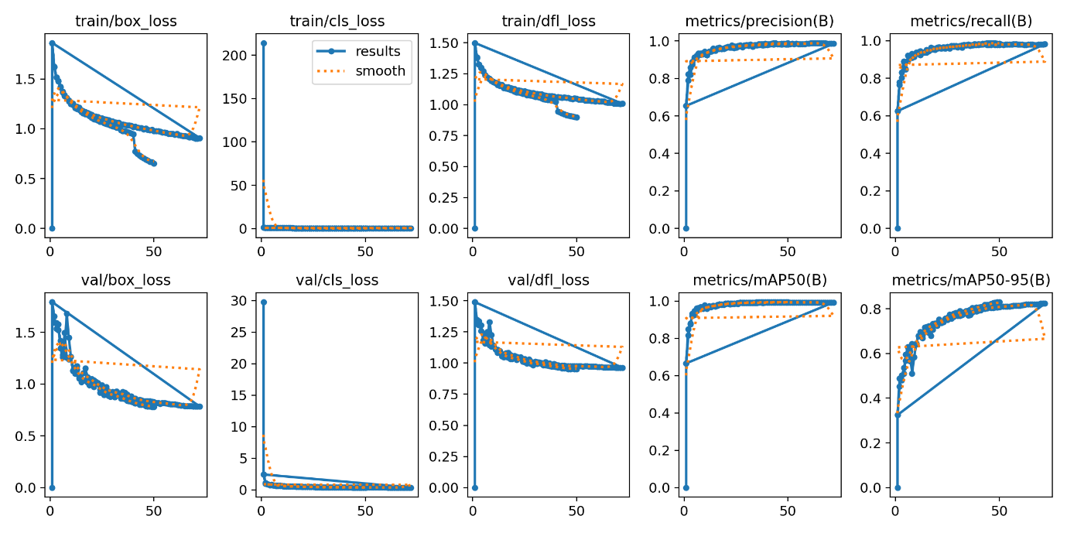

**2. Inference Performance**

**2.1 Dataset Information**

* **Test Dataset Used:** inferencing_1.mp4
* **Number of Images Tested:**
* **Resolution of Images Used for Testing:**

**2.2 Inference Results**

|  |  |
| --- | --- |
| **Metric** | **Value** |
| FPS (Frames per Second) |  |
| Average Inference Time (ms) |  |
| Precision (%) |  |
| Recall (%) |  |
| mAP@50 (%) |  |
| mAP@50-95 (%) |  |
| Number of False Positives |  |
| Number of False Negatives |  |

* **Observations on Inference Quality:**  
  (Does it detect all expected objects? Are there misclassifications?)
* **Example Detections (Screenshots with annotations attached)**

**3. Model Performance Comparison**

|  |  |  |
| --- | --- | --- |
| **Metric** | **Pre-Fine-Tuning** | **Post-Fine-Tuning** |
| Training Loss |  |  |
| mAP@50 |  |  |
| FPS |  |  |

* **Performance Gains Observed (if any):**

**4. Issues & Challenges**

* **Any anomalies in detection?**
* **Dataset-related issues?**
* **Overfitting/underfitting observed?**
* **Any other difficulties faced?**

**5. Next Steps & Recommendations**

* **Suggestions for further improvements:**
* **Need for additional training or dataset enhancement?**
* **Hardware or software limitations noticed?**
* **Plan for the next iteration:**

**Notes / Additional Comments**

(Any extra remarks or insights)